Financial Empowerment: Mortgage Amortization Calculator

Team 7: MortiSmart

Carlos Martinez, Ricardo Carvalheira, Ricardo Ehringer, Thomas Martin

CEN3031

University of Florida

09.24.2023

Table of Contents

1 List of Contributors 3

2 Project Languages 3

3 Problem Statement 3

4 Solution Overview 3

5 Key Features and Functionality 4

6 Project Vision 4

7 Risk Management Plan 5

7.1 Avoidance 5

7.2 Minimization 5

7.3 Contingency Planning 5

7.4 Risk Assessment 6

9 Setup 7

9.1 GitHub Repository 7

9.2 Configuration Management 7

9.4 Project management tool 9

# 1 List of Contributors

* Product Manager: Ricardo Carvalheira
* Scrum Master: Thomas Martin
* Development Team Member: Carlos Martinez
* Development Team Member: Ricardo Ehringer

# 2 Project Languages

* Javascript,
* HTML
* CSS

# 3 Problem Statement

In today's world, where financial literacy and empowerment are critical issues, there is a pressing need for a software product that provides practical financial tools and addresses the lack of understanding and awareness about mortgage amortization. Many individuals, particularly first-time homebuyers, often find themselves unaware of the long-term financial implications of their mortgage choices. This lack of knowledge can lead to financial stress and instability as well as contribute to broader social issues like household debt, housing insecurity, and economic inequality.

# 4 Solution Overview

Our goal is to develop a user-friendly and feature-rich Mortgage Amortization Calculator that not only assists users in calculating their monthly mortgage payments and total interest, but also informs and educates them about the long-term financial impacts or risks of their mortgage decisions. This tool will empower users to make informed choices when it comes to home financing, ultimately contributing to the financial stability and well-being of themselves and society at large.

# 5 Key Features and Functionality

Mortgage Calculation: Users can input essential details, such as loan amount, interest rate, and loan term. The calculator will instantly provide them with their monthly payment amount and total interest over the life of the loan. Allow users to print this data in .csv.

Amortization Schedule: Users can access a detailed amortization schedule, breaking down each monthly payment into principal and interest components. This feature helps users visualize how their payments contribute to reducing the principal balance over time. Allow users to print this data in .csv.

Impact of Additional Payments: Users can experiment with different scenarios by making additional payments and see how these extra contributions affect the loan's duration and the amount of interest saved. This educates users about the power of paying more than the minimum required. Allow users to print this data in .csv.

Interactive Data Visualization: To enhance user engagement and understanding, the tool will include interactive charts and graphs that illustrate the impact of amortization on their financial situation. Users can also modify their plans and generate to better visualize and plan the overall scope and plan of their changing situation.

# 6 Project Vision

FOR first-time homebuyers and individuals seeking financial empowerment, OUR PROJECT, "Financial Empowerment: Mortgage Amortization Calculator," is a Javascript-based solution THAT addresses the pressing need for a user-friendly Mortgage Amortization Calculator. WHO faces the problem of needing more understanding of mortgage amortization and its long-term financial implications. Unlike other mortgage calculators, OUR PRODUCT calculates monthly payments and total interest and educates users about their mortgage decisions. The key benefit of OUR PRODUCT is the empowerment of users to make informed choices about home financing, ultimately contributing to their financial stability and the well-being of society.

# 7 Risk Management Plan

We will collect information during the project so that we can better handle any risks that might occur.

## 7.1 Avoidance

We clearly defined the project scope and objectives to set proper expectations. We decided to deliver a minimum viable product (MVP) with minimal functionality to avoid overpromising and underdelivering. As the project evolves during the sprints, we will add more user stories with enhancements and new features. Also, to prevent issues integrating software, we are establishing ground rules to fetch and pull before working on any new enhancement to ensure our branches are up to date.

## 7.2 Minimization

We protect the main branch from pull requests without someone else’s approval. So, code reviews will occur on every Pull Request (PR) to ensure no conflicts in the merge. We require a few checks to pass before merging using CircleCI. To minimize bugs from broken links, We will use Test Driven Development (TD) to minimize unexpected issues. The CircleCI integration will require the tests to pass before merging PR into the main branch. Further, we’ll assign user stories proportional to what each team member can contribute and deliver during the sprint. We will also meet daily to discuss what each member was able to complete the previous day, what roadblocks they are facing, and what they will work on next.

## 7.3 Contingency Planning

Should a collaborator be unable to complete the task, we will have another team member assist them. Should a collaborator have personal problems or become ill, we’ll reassign their story points to the other members.

## 7.4 Risk Assessment

|  |  |  |
| --- | --- | --- |
| **Explanation** | **Probability** | **Effects** |
| Development difficulties because of complex or novel features or implementations | Moderate | Serious |
| Additional features are requested and require development, increasing scope of project and consuming further resources | Moderate | Serious |
| Users dissatisfied with layout of interface or graphs/images | Moderate | Serious |
| Competitors creating similar products, drawing users away from product to theirs | High | Tolerable |
| Personal finance planning services become more widely available | Low | Insignificant |
| Significant economic downturn which turns customers away from buying property as well as impacts project funding | Moderate | Catastrophic |
| Key collaborators are ill at critical times in the project | Moderate | Serious |
| Faith in reusable software components must be repaired before these components are reused. | Moderate | Serious |
| The time required to develop the software is underestimated | High | Serious |
| Software tools and features cannot be integrated | High | Tolerable |
| Required training for staff is not available | Moderate | Tolerable |
| The rate of defect bugs is underestimated | Moderate | Tolerable |
| Code generated by code generation tools is inefficient | Moderate | Insignificant |
| Key collaborators have family situations at critical times in the project | Moderate | Serious |
| Staff does not have adequate skills to develop | Moderate | Serious |
| Changes to requirements that require major design rework are proposed | Moderate | Serious |

# 9 Setup

# 9.1 GitHub Repository

<https://github.com/ricardocarva/MortiSmart>

# 9.2 Configuration Management

CircleCI initial setup in the image below.

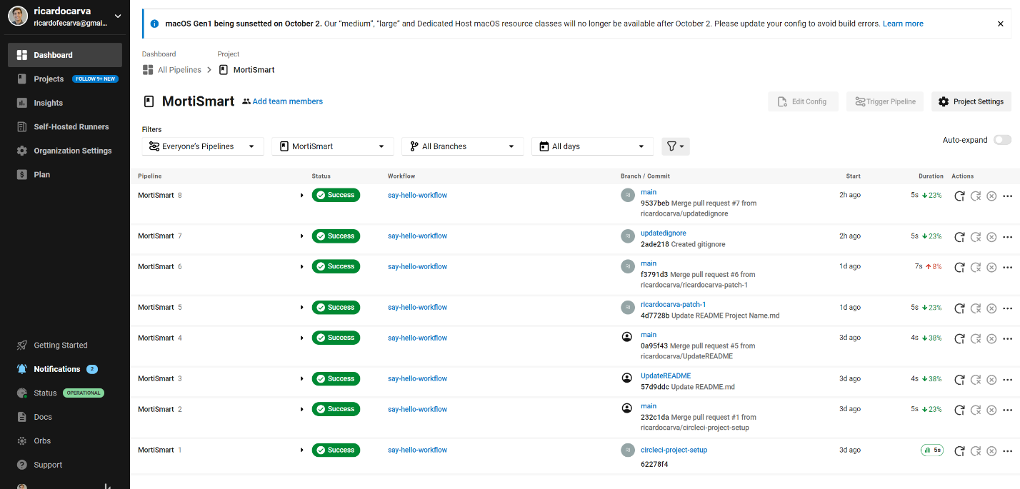

Figure 1: CircleCI: Hello World

9.3 Configure Master Branch

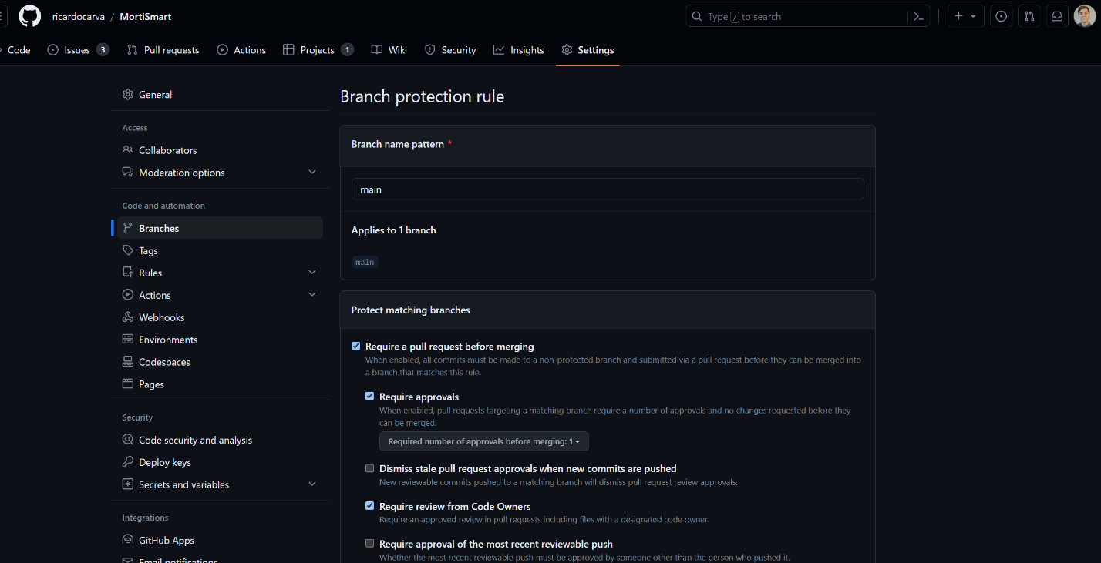

Figure 2: Top portion of the Branch Protection Rule

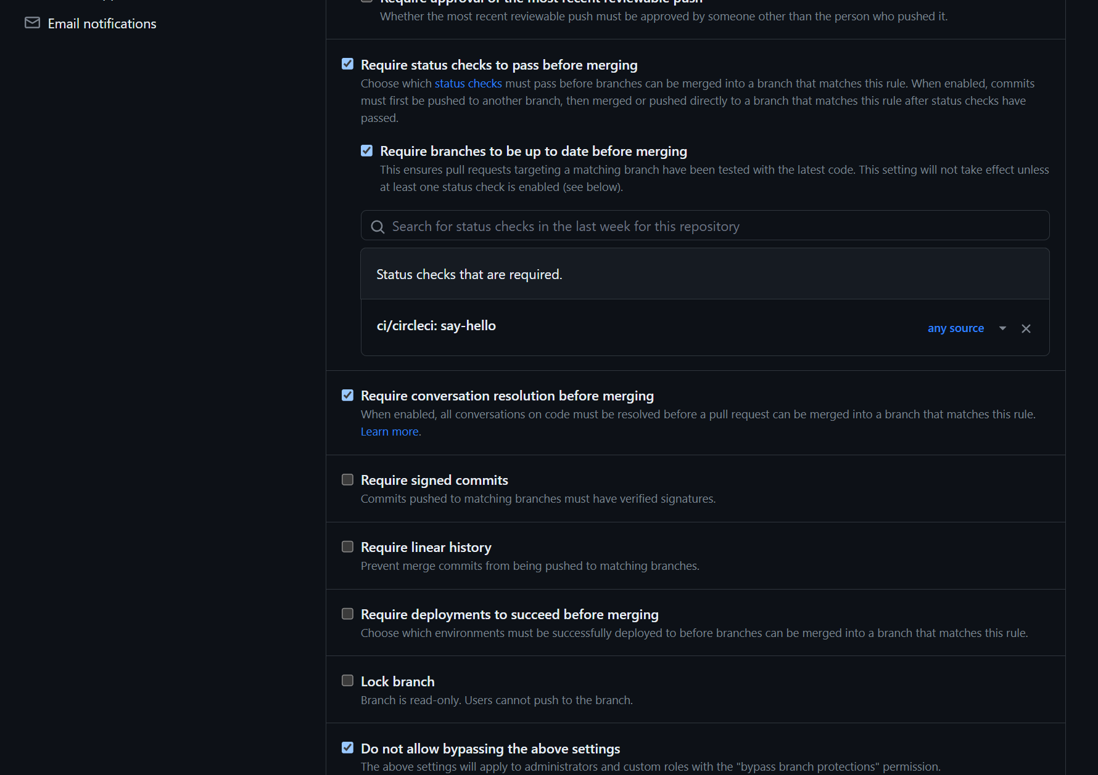

Figure 3: Middle portion of the Branch Protection Rule



Figure 4: Bottom portion of the Branch Protection Rule

# 9.4 Project management tool

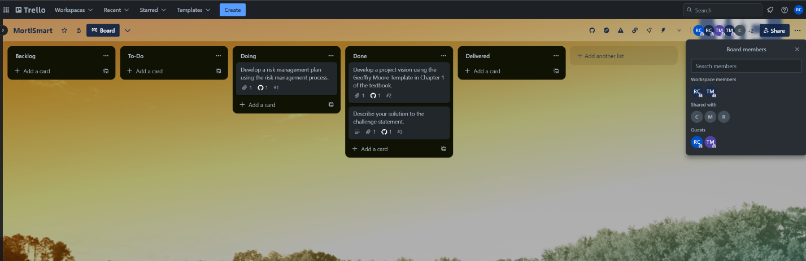

Figure 5: Trello Board for the project